**A**

**PROJECT REPORT**

**ON**

**COURIER MANAGEMENT SYSTEM**

BACHELOR’S OF SCIENCE

IN

COMPUTER SCIENCE

**SUBMITTED BY**

**NEHA SAPKAL**



**S.K. COLLEGE OF SCIENCE AND COMMERCE,**

**PLOT NO.31, SEC.25, SEAWOODS , NAVI MUMBAI – 400706**

**2024-25**

**A**

**PROJECT REPORT**

**ON**

**COURIER MANAGEMENT SYSTEM**

BACHELOR’S OF SCIENCE

IN

COMPUTER SCIENCE

**SUBMITTED BY**

**NEHA SAPKAL**

PROJECT GUIDE

DR. SHRADDHA SABALE

**S.K. COLLEGE OF SCIENCE AND COMMERCE,**

**PLOT NO.31, SEC.25, SEAWOODS , NAVI MUMBAI - 400706**

**2024-25**

**ABSTRACT**

COURIER MANAGEMENTSYSTEM designed to streamline the process of managing courier services, from order placement to delivery. The system provides a comprehensive solution for handling the logistics of courier services, including package tracking, delivery Managing branches and real-time updates. By automating these processes, the system enhances efficiency, reduces errors, and improves customer satisfaction.

The Courier Management System supports various roles, such as administrators, couriers, and customers, each with tailored functionalities and access levels. The system's architecture is built with scalability and security in mind, ensuring that it can handle the demands of both small and large courier companies. Key features include real-time package tracking, automated dispatching, route optimisation, and a robust notification system to keep all parties informed.

This project was developed following an analysis of existing courier systems, identifying key areas for improvement. The resulting system is a user-friendly, reliable, and scalable solution that addresses the challenges faced by courier services, ultimately leading to faster, more efficient deliveries and enhanced customer experience.

**ACKNOWLEDGEMENT**

I would like to express my special thanks of gratitude to my project guide **Dr. Shraddha sable**  for their guidelines and support in making my project successful.

I am very thankful to our principal **Dr. Swati Vitkar**  for their kind cooperation in completion of my project.

I am also grateful to **Mrs. Vrushali Ghatpande** , head of department for being very much resourceful, kind and helpful. And also thankful for their positive attitude, time and efforts she provided to us. Your useful advices gives us confidence to do project successfully.

I also wish to thanks our lab assistant and all my friends and entire **computer department** who helped me in completion of my project.

Last but not the list I would like to thank my family without whose support , motivation and encouragement it would not have been possible.

**PREFACE**

It gives me great pleasure to present the project on “**COURIER MANAGEMENT SYSTEM**” prepared sincerely, punctually and with utmost efforts.

The contents of this book are presented into many chapters, in order to ease reading. The project has been illustrated with precise data elucidated with precise data elucidated with neat Use Case Diagram and Activity Diagram that simplify the understanding of the project. The project includes the software development tools like Apache, PHP, MYSQL.

Meticulous care has been taken to make this project perfect and useful in every respect.

**NEHA SAPKAL**

**DECLARATION**

I the undersigned **Miss. Neha sapkal** hereby, declare that the work embodied in this project work titled **“COURIER MANAGEMENT SYSTEM”** forms my own contribution to the research work carried out under the guidance of **Dr. Shraddha sable** is a result of my own research work and has not been previously submitted to any other University for any other Degree/ Diploma to this or any other University.

Wherever reference has been made to previous works of others, it has been clearly indicated as such and included in the bibliography.

I will abide and take all responsibility of all issues related to plagiarism/self-plagiarism mentioned under UNIVERSITY GRANTS COMMISSION (PROMOTION OF ACADEMIC INTEGRITY AND PREVENTION OF PLAGARISM IN HIGHER EDUCATIONAL INSTITUTIONS) REGULATIONS, 2021.

I, here by further declare that all information of this document has been obtained and presented in accordance with academic rules and ethical conduct.

Submitted by Certified by

Neha Sapkal



**INDEX**

|  |  |
| --- | --- |
| INDEX | TOPIC |
| 1 | **PRELIMINARY INVERTIGATION** |
|  | a. INTRODUCTION |
|  | b. DEVELOPMENT TOOLS |
|  | c. FEATURES |
|  | d. LIMITATIONS |
|  | e. DESCRIPTIONS SYSTEM |
| 2 | **SYSTEM REQUIREMENTS** |
|  | a. SOFTWARE REQUIREMENTS |
|  | b. HARDWARE REUIREMENRTS |
| 3 | **SYSTEM ANALYSIS** |
|  | a. ER-DIAGRAM |
| 4 | **SYSTEM CODING** |
|  | a. VALIDATION CODE |
|  | b. DATA SET |
| 5 | **SYSTEM DESIGN** |
| 6 | **FUTURE ENHANCEMENT** |
| 7 | **CONCLUSION** |
| 8 | **REFERENCES AND BIBLIOGRAPHY** |

1. **PRELIMINARY INVERTIGATION**

**INTRODUCTION**

Courier Management System designed to streamline the process of managing courier services, from order placement to delivery. The system provides a comprehensive solution for handling the logistics of courier services, including package tracking, delivery scheduling, and real-time updates. By automating these processes, the system enhances efficiency, reduces errors, and improves customer satisfaction.

The Courier Management System supports various roles, such as administrators, couriers, and customers, each with tailored functionalities and access levels. The system's architecture is built with scalability and security in mind, ensuring that it can handle the demands of both small and large courier companies. Key features include real-time package tracking, automated dispatching, route optimisation, and a robust notification system to keep all parties informed.

This project was developed following an analysis of existing courier systems, identifying key areas for improvement. The resulting system is a user-friendly, reliable, and scalable solution that addresses the challenges faced by courier services, ultimately leading to faster, more efficient deliveries and enhanced customer experience.

**DEVELOPMENT TOOLS**

**FRONT-END :** PHP

**BACK-END:** PHP,MYSQL Workbench(Database)

**OPERATING SYSTEM :** Windows 11

**FEATURES**

1. New information can get added easily.
2. Admin can easily operate the system.
3. It gives you full of security .
4. It is a user friendly application.
5. Leave details of any Couriers and staff we can retrieve easily.
6. Fees related information can be easily known to all students.
7. Overall application is useful.

**LIMITATIONS**

* Admin and staff both can do any changes in the data.
* Staff training is required for effective system use.
* System depends on accurate data input to function correctly
* Ongoing maintenance and upgrade are essential for optimal performance.
* Data privacy and security concerns

**DESCRIPTION OF THE SYSTEM**

The **Courier Management System** aims to enhance the efficiency of managing courier operations, including package tracking, delivery scheduling, and customer service. It provides a comprehensive platform for handling courier tasks, from package pickup to final delivery, and offers real-time visibility into the status of deliveries

Key Features:

1. Use MYSQL database which is one of the best database.
2. Use of password protection.
3. All data can get entered easily.
4. It helps to manage and track parcels efficiently.
5. It helps to show the detailed report about parcels.
6. It can give you details just by using tracking id.

By implementing these features and adhering to the requirements, the Courier Management System will significantly improve the efficiency and effectiveness of courier operations, benefiting both the company and its customers.

1. **SYSTEM REQUIREMENTS**
2. **SOFTWARE REQUIREMENTS**

* Apache And Mysql Xampp
* Any operating system

1. **HARDWARE REUIREMENRTS**

* Any laptop or PC with specific software.

1. **SYSTEM ANALYSIS**

**1.ER Diagram**



1. **SYSTEM DESIGN**

1.Login page

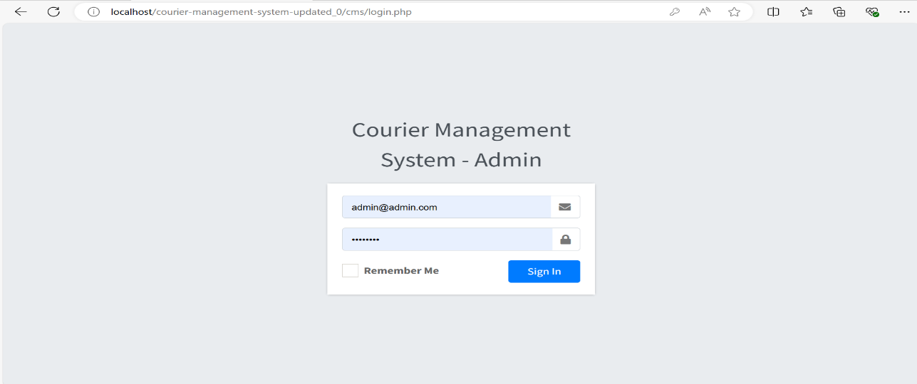

2. Home Page

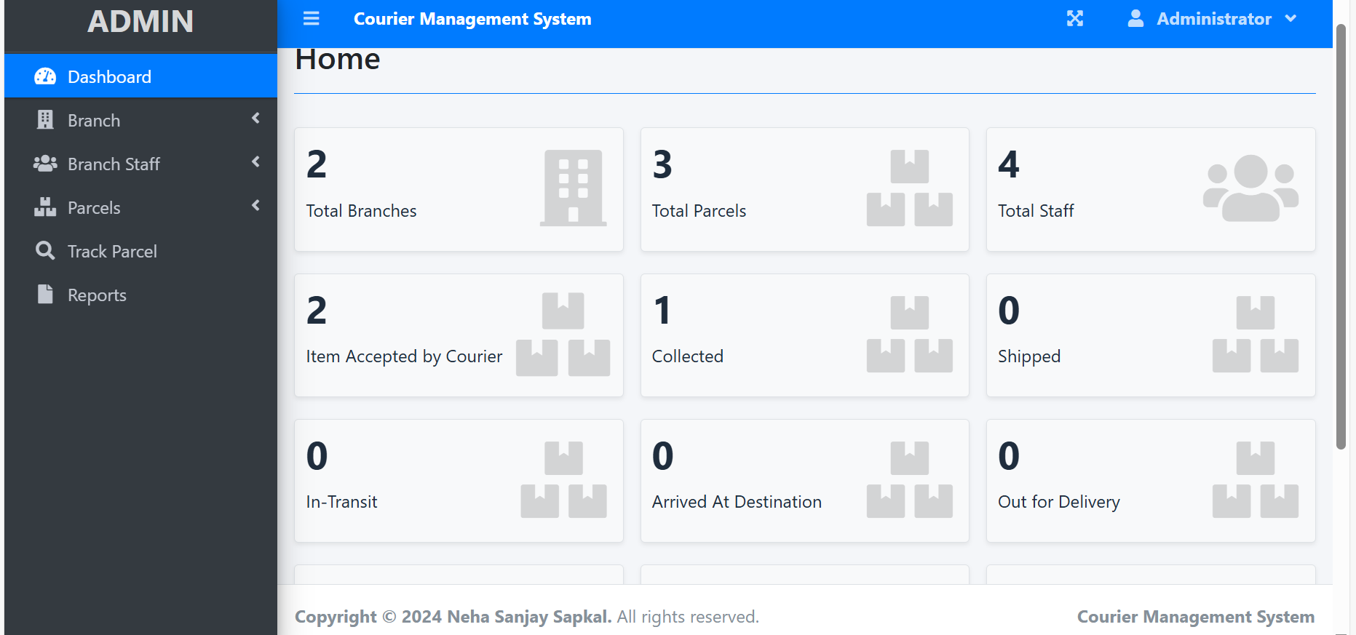

3.For adding new Branch information.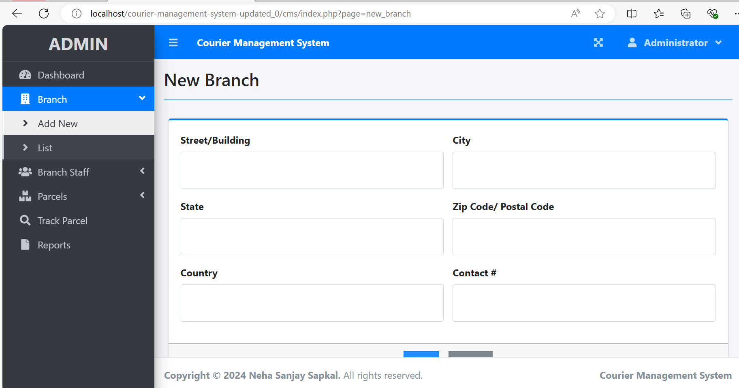

4.For viewing list of all Branches.

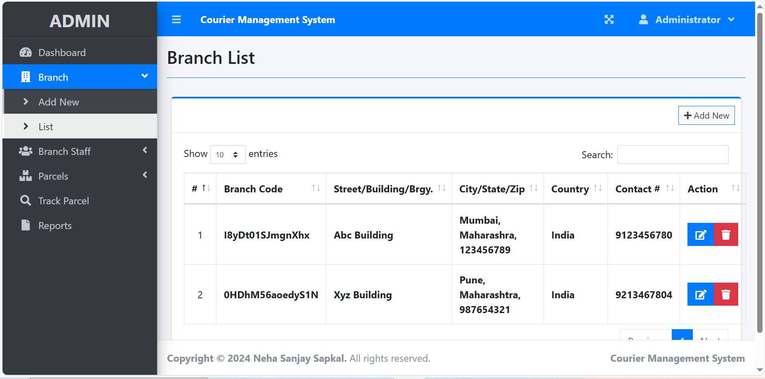

5.Pages for adding new branch staff.

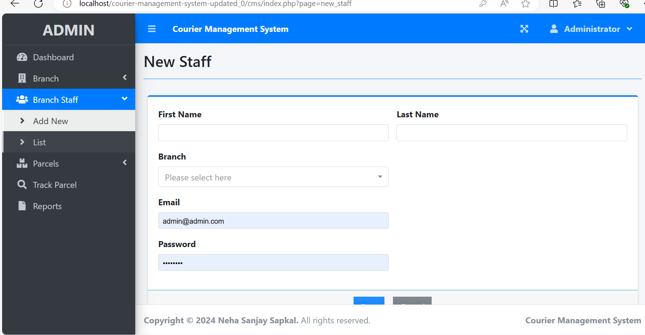

6.For viewing staff list.

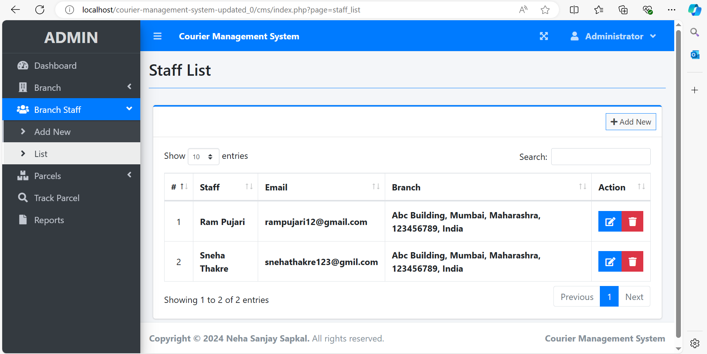

7.For Adding New Parcel to management system.

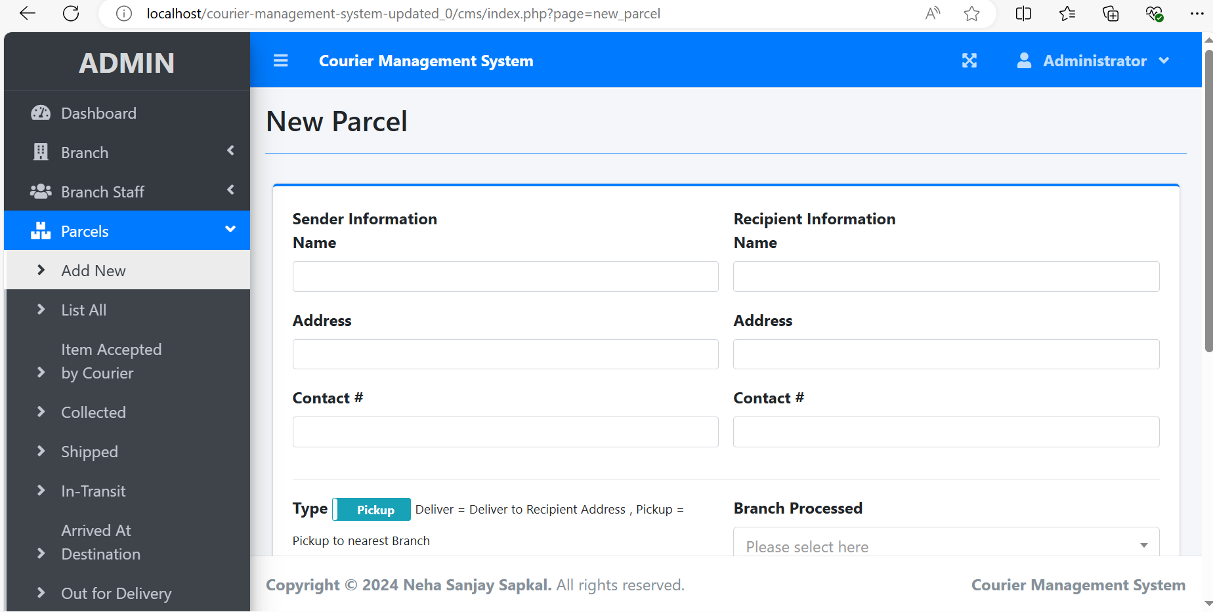

8.Page to list all the parcels.

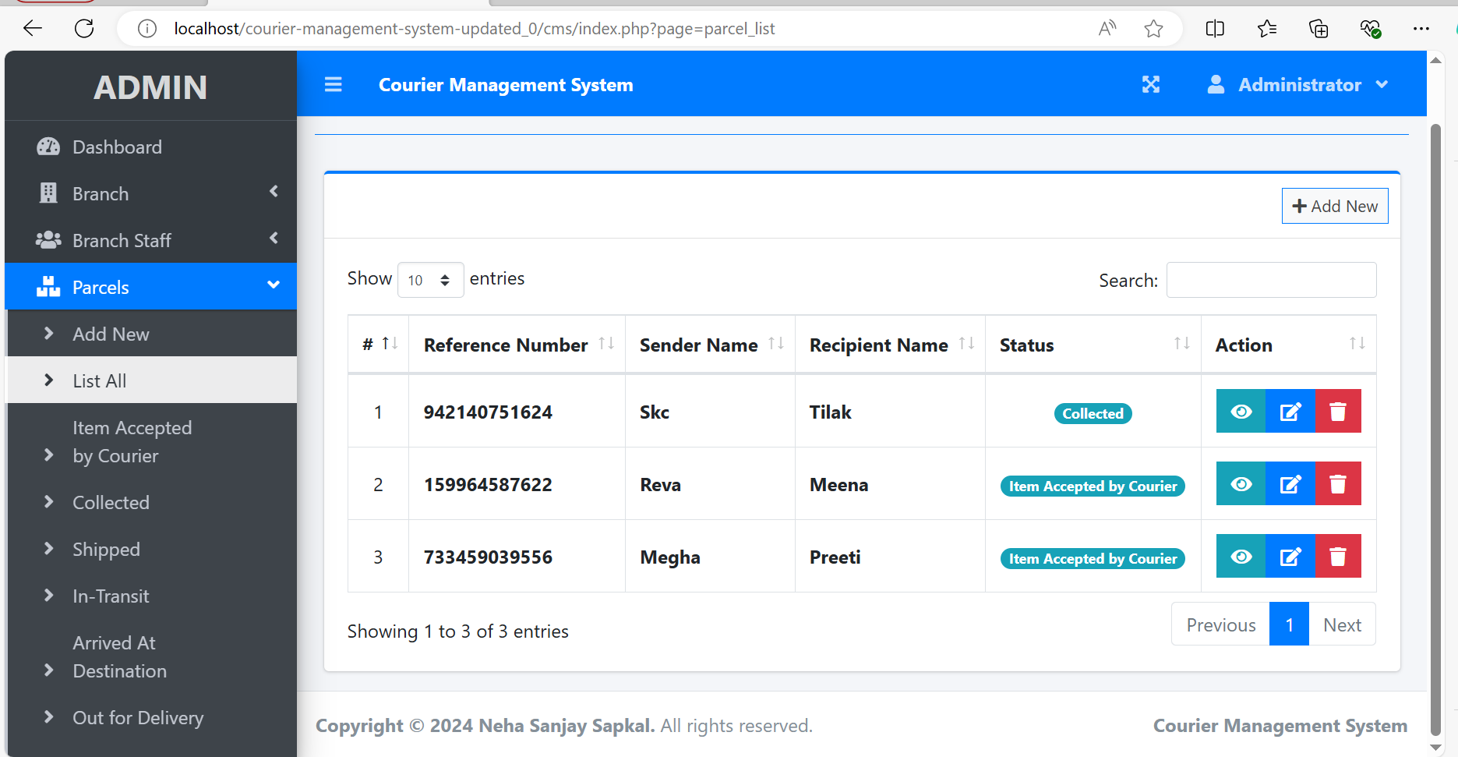

9.For tracking the parcel using Tracking id.

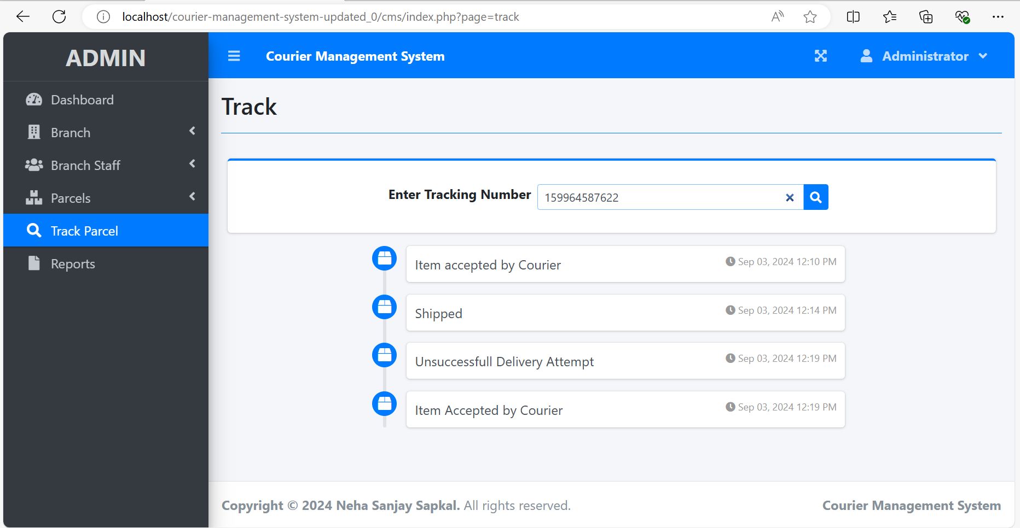

10.For getting the details about the parcel.

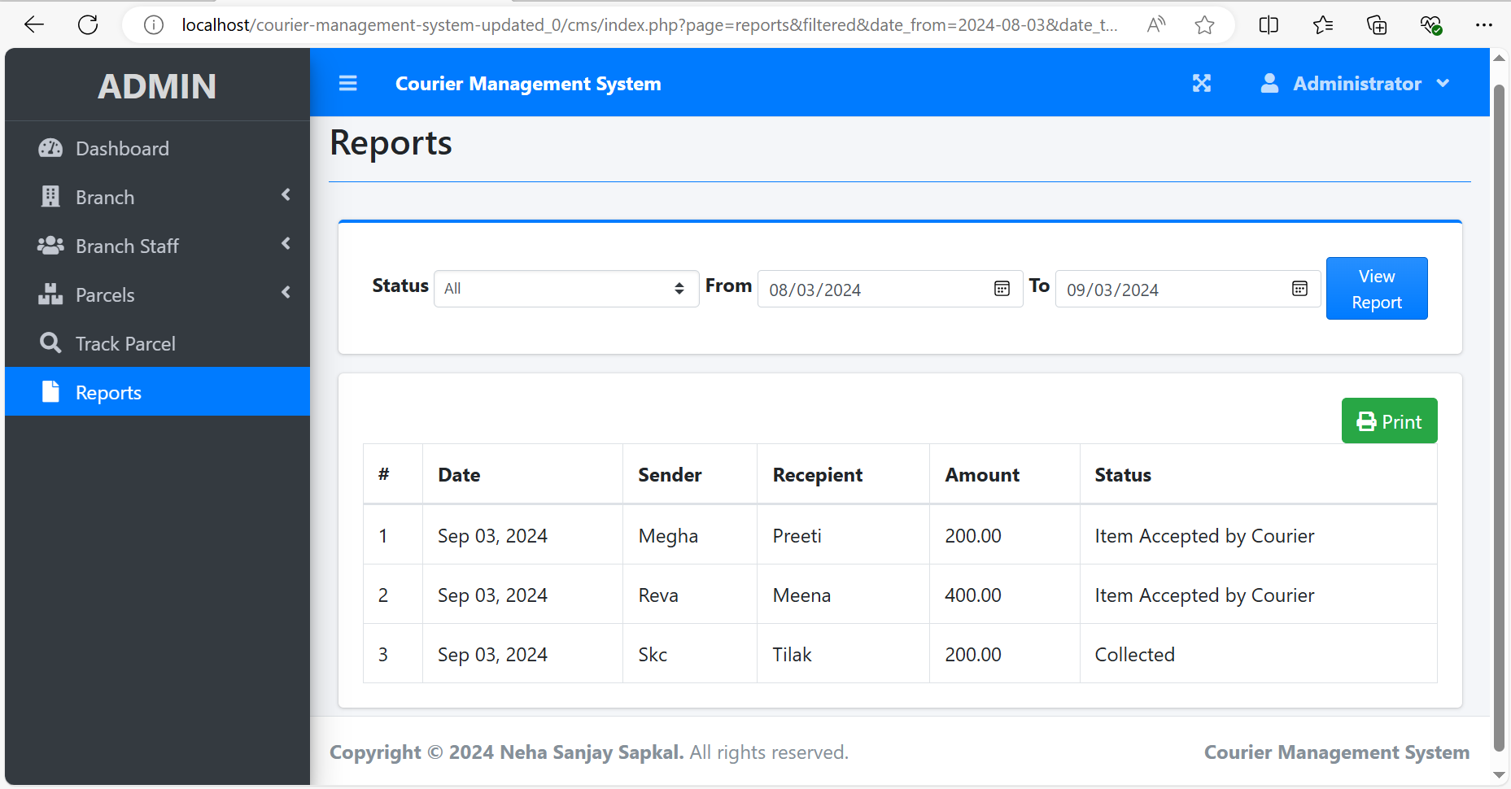

11. Page for staff login.

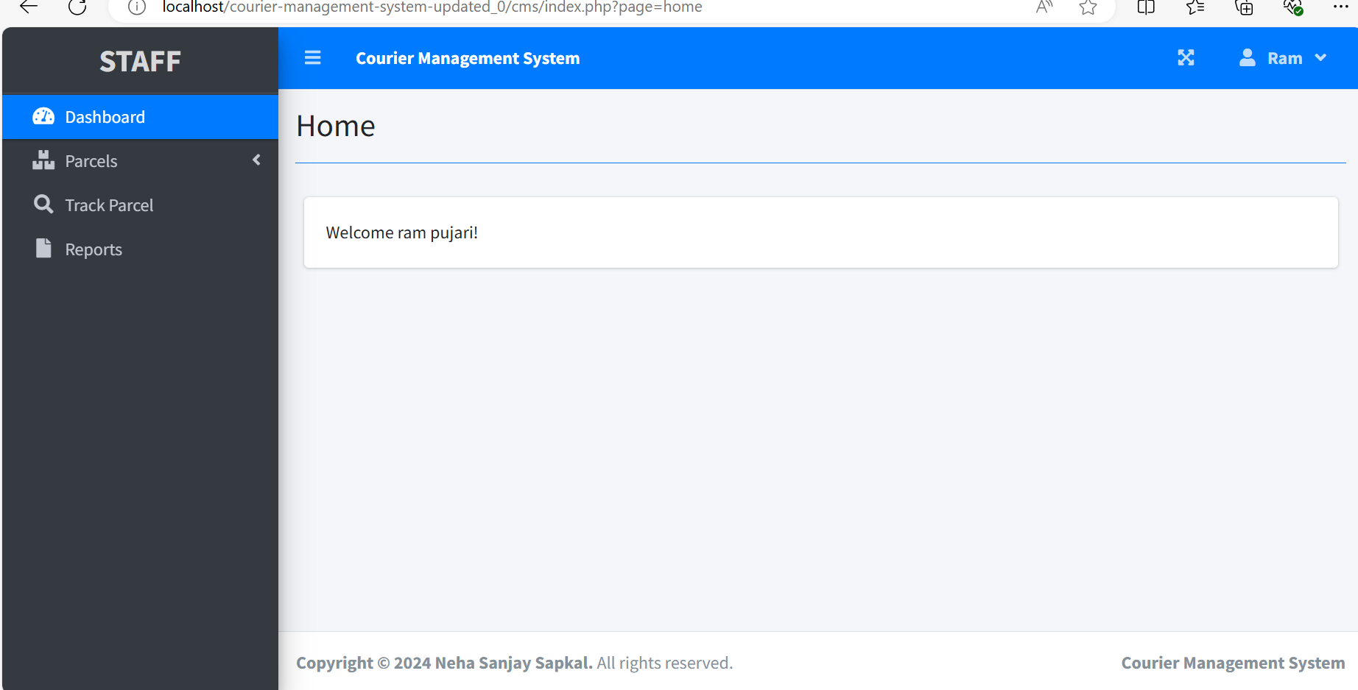

11. Manage account page for Admin

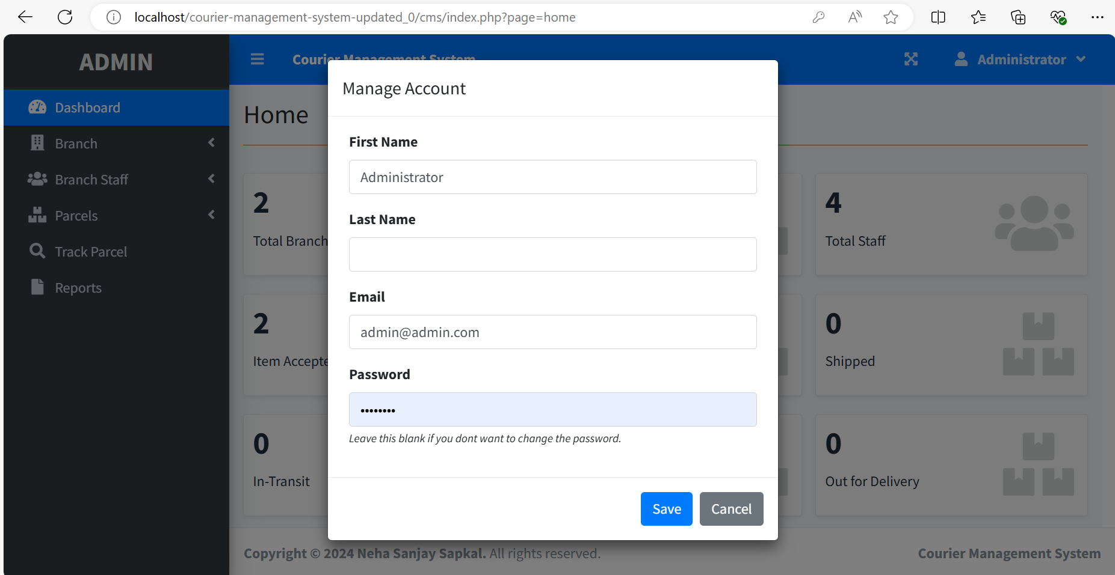

1. **VALIDATION CODE**

**1.Validation part in adding new staff for First name, Last name, Email and Password.**

**<?php if(!isset($conn)){ include 'db_connect.php'; } ?>**

**<style>**

**textarea{**

**resize: none;**

**}**

**</style>**

**<div class="col-lg-12">**

**<div class="card card-outline card-primary">**

**<div class="card-body">**

**<form action="" id="manage-staff">**

**<input type="hidden" name="id" value="<?php echo isset($id) ? $id : '' ?>">**

**<div class="row">**

**<div class="col-md-12">**

**<div id="msg" class=""></div>**

**<div class="row">**

**<div class="col-sm-6 form-group ">**

**<label for="" class="control-label">First Name</label>**

**<input type="text" name="firstname" id="" class="form-control form-control-sm" value="<?php echo isset($firstname) ? $firstname : '' ?>" required>**

**</div>**

**<div class="col-sm-6 form-group ">**

**<label for="" class="control-label">Last Name</label>**

**<input type="text" name="lastname" id="" class="form-control form-control-sm" value="<?php echo isset($lastname) ? $lastname : '' ?>" required>**

**</div>**

**</div>**

**<div class="row">**

**<div class="col-sm-6 form-group ">**

**<label for="" class="control-label">Branch</label>**

**<select name="branch_id" id="" class="form-control input-sm select2">**

**<option value=""></option>**

**<?php**

**$branches = $conn->query("SELECT *,concat(street,', ',city,', ',state,', ',zip_code,', ',country) as address FROM branches");**

**while($row = $branches->fetch_assoc()):**

**?>**

**<option value="<?php echo $row['id'] ?>" <?php echo isset($branch_id) && $branch_id == $row['id'] ? "selected":'' ?>><?php echo $row['branch_code']. ' | '.(ucwords($row['address'])) ?></option>**

**<?php endwhile; ?>**

**</select>**

**</div>**

**</div>**

**<div class="row">**

**<div class="col-sm-6 form-group ">**

**<label for="" class="control-label">Email</label>**

**<input type="email" name="email" id="" class="form-control form-control-sm" value="<?php echo isset($email) ? $email : '' ?>" required>**

**</div>**

**</div>**

**<div class="row">**

**<div class="col-sm-6 form-group ">**

**<label for="" class="control-label">Password</label>**

**<input type="password" name="password" id="" class="form-control form-control-sm" <?php echo isset($id) ? '' : 'required' ?>>**

**<?php if(isset($id)): ?>**

**<small class=""><i>Leave this blank if you dont want to change this</i></small>**

**<?php endif; ?>**

**</div>**

**</div>**

**6.FUTURE ENHANCEMENT**

* For any system that is developing, there is always way for more development.
* The Courier Management System has a lot of enhancement options.
* Some of future enhancement we can do in future version are as follows :

1. In future more features may be added category-wise.
2. Can also add option so that users can themself place the order for parcel delivery without visiting nearest store.
3. Can also add online payment for parcel charges.

**7.CONCLUSION**

* It has user-friendly interface so user can use system easily with the basic knowledge of computer.
* This software will help admin for storing data easily.
* Proper testing has been done by developer.
* This software is secure as it has proper authentication system .
* It can keep all your data stored for a long duration.
* It will give you all the data when you need it within some time.

**8.REFERENCES AND BIBLIOGRAPHY**

* [**www.google.com**](http://www.google.com)
* [**www.youtube.com**](http://www.youtube.com)